**Guide to participate in the selection process:**

You must complete the following #challenges to advance in the recruitment process, **remember that it is not necessary to complete all the tests**, but most of them, we wish you good luck in this process - additional you must send link of public repositories where you have worked with the language for which you are applying (this to analyze code written by you).

**1. "Too many tasks, not enough speed":**

In the company is developing a system that is responsible for sending different reports (emails) to many recipients, then there is a problem that for each sending - it takes time to get the mails out and if one of the mails presents a problem the sending queue is broken - then the company is looking for you to be able to develop a system that can run these mails keeping in mind that your solution must solve the following points:

**Tasks:**

* Mails must now be processed separately and in parallel.
  + Mail pending processing
  + Mails under retry process
  + Priority mails
* Get each mail queue (pending, retry, priority) to run in different processes, each queue processing process should run the same in N number of defined sub processes (recommended 8 sub processes).
* When the script finishes it must execute certain tasks:
  + Saving process of a .txt file with the information or report of the sent emails, where information such as: id, number of attempts, if it is a priority or not, example: 101, 6, true
* Show in console how long it took (in seconds) to process all the mails (from all the queues).
* Save a graph in .jpeg format representing the following information.
  + Number of emails executed per 0.5 seconds.
  + Number of failed emails per 0.5 seconds.
  + Number of new emails added to the queue per 0.5 seconds.

**The following is the code that has the described problem:**

* Python: <https://bitbucket.org/creed-and-bear/recruiting-test-python-01/src/master/>

**Remember:**

You should refactor the actual code, you should not change the methods that are marked.

**2. "Ecosystem of services".**

The company is looking to develop a series of microservices in charge of managing the information of some investors, so the developer responsible for this activity needs to be able to perform the following tasks:

* Create a service where you create an Investor
* Create a service where you delete an Investor
* Create a service where you modify an Investor
* Create a service where you list inverters and we can make search filters such as name, email, phone (do not forget the paging).
* Create the respective routes for the authentication process for the later use of the rest of the routes.

**Entity "investor" must contain at least the following information:**

* Name
* Email
* Phone

**Keep in mind that:**

* The database you will use for this example will be a JSON file oriented database inside the project folder (DO NOT USE DATABASE LIKE MYSQL, SQL SERVER OR OTHER).
* Must use a microservices based architecture.
* You must use the "repository" pattern for the management of the models that are in charge of working the data.
* Remember to use unit tests.
* Remember to apply security to the routes, for example JWT or other type of security.
* You should use functional programming as little as possible, use object-oriented programming instead.
* Do not forget the S.O.L.I.D. principles.

**At the end of this test:**

* Upload the documentation of your services to POSTMAN and send the "collection.json".

**3. Welcome**

Welcome to Creed and Bear, a company full of people beautiful, talented and with a deep desire to never stop learning, creating, building, making the impossible… possible. We want to welcome you by proposing a challenge, find how many times a phrase is repeated in a text, because if you paid attention, the number of times "Welcome to Creed and Bear" is repeated in this paragraph is 32630504042 times.

The problem consists of counting all the possible subsequences of a sentence in a given text.

**Inputs:**

The first entry is an integer P representing the number of test cases. For each test case you will receive two lines: the first one a sentence S and the second one the text T where you should look for the number of subsequences.

**Outputs:**

For each test case you shall print the number of subsequences that exist in the data text.

**Limits:**

Maximum time for each test case: 20s.

P < 1000000

**Examples:**

| **Inputs** | **Ouputs** |
| --- | --- |
| 3 |  |
| **bienvenido a creed and bear**  bienbienvenido a creeandedandbear and beaar | 70 |
| **hola**  Un oso cogió un hilo dental para limpiar sus dientes | 4 |
| **papaya**  me gustan las peras | 0 |

**4. Math homework**

Roberto is a young student at "eche" school who likes mathematics and computer science. One day his math teacher set him a challenge, to create an algorithm that, given a number K, would find two prime numbers (A and B) that multiplied together would give the same number. Roberto has no idea where to start. He helps Roberto build the algorithm.

**Inputs:**

The first input is an integer P representing the number of test cases. For each test case you will receive an integer K representing the product of the multiplication between A and B.

**Outputs:**

For each test case you must print the integers A and B separated by spaces.

**Limits:**

Maximum time for each test case: 20s A, B < K <= 10^9.

P < 1000000

**Examples:**

| **Inputs** | **Outputs** |
| --- | --- |
| **3** |  |
| **38585507** | 7759 4973 |
| **1963** | 151 13 |
| **1271** | 31 41 |

**5. Heritage**

A group of families within a village of former landowners initiated a division process. This process is a bit particular because each of the heirs does not seek to have more or equal surface of land than the others, instead, they only seek to divide in equal parts the places that bring with them precious mineral ores. The land of each of the former heirs is a plan of R rows and C columns, where each of the cells represents one hectare of surface, which may or may not have an ore in it. The dividing process will be carried out with a series of vertical and horizontal cuts to the plan. Thelawyers of each of the families have the task of carrying out a peaceful and transparent process ensuring that each of the heirs has the same amount of ores, regardless of the surface.

It helps the lawyers to carry out the separation.

**Inputs:**

The first input is an integer P representing the number of test cases. For each test case you will receive 3 integers: N, R and C where: N represents the number of heirs and where R and C represent the dimensions of the plan. Then in the following "inputs" you will receive the information of each of the rows of the plan, where each hectare with an ore is represented by "+" and each empty hectare is represented by ".".

**Outputs:**

For each test case you shall print the X coordinates of the vertical cuts (each separated by comma (","), starting from 0) and space separated the Y coordinates of the horizontal cuts (each separated by comma (","), starting from 0). In case there are no cuts (either vertical or horizontal) print a hyphen ("-"). In case it is impossible to make the division print the word: IMPOSSIBLE.

**Limits:**

Maximum time per test case: 20s.

1 < R, C, N <= 1000

P < 1000000

**Examples:**

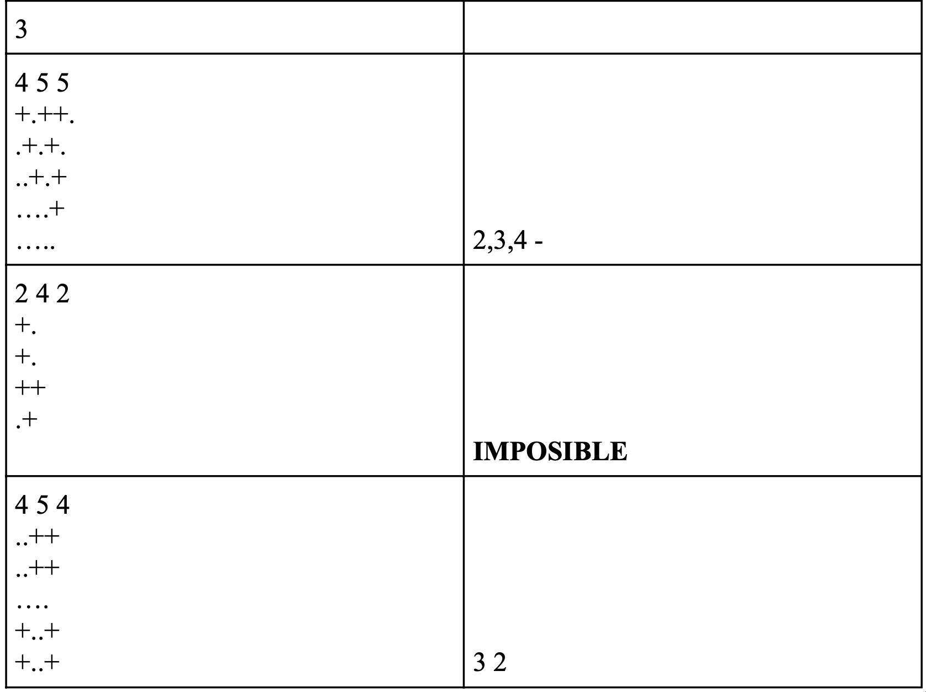

**Explanation:**

* In the first test case, we have: 4 heirs and a 5x5 plot of land. Here we simply count the number of available ores and take the residue of the division with the number of heirs. When we find that it is 0, we know that we have to give 2 ores to each one and we proceed with the division. In this case there are only vertical cuts, so no dash is printed in the second space.
* In this case we mark that it is impossible because we only have two heirs and 5 ores, it is not possible to do the division process in this case.
* In this case, it is possible to do the division process, since there are 4 heirs and there are 8 hectares with ores available, then we look for the cuts. In this case, unlike the first one, there are vertical and horizontal cuts.

**Note:** For each problem you solve, the following criteria will be taken into account (ordered in such a way that the first one is the one that is taken into account the most and the one that is taken into account the least):

* Efficiency of the Algorithm, the faster and shorter the better.
* Correct use of classes and functions
* Code modularization, the more compact and separated the responsibilities.
* [S.O.L.I.D](https://en.wikipedia.org/wiki/SOLID)
* [Programming Style](https://en.wikipedia.org/wiki/Programming_style)

**When you finish the test you should send an email with the following information:**

* You must create and submit a public link to a repository with the completed TEST (please use only 1 repository for every 1 completed TEST).
* Add to your repository some result images of your working code.